Adam Livingston

Professor Dr. Pavan Reddy

ENGV 306 Advanced Composition

26 June 2022

Housing First: The Best Solution for Solving Homelessness

The occasional street garbage has grown into mountains. Dilapidated tent cities find refuge under freeway overpasses. Sight and stench of human feces have become commonplace. What was once treated unsympathetically as a natural, fleeting eyesore is now an unignorable national crisis. Solving homelessness has always been a challenge. Victims of homelessness have traditionally been subjected to following Staircase Models (SM) of support. SMs are “designed to prepare someone for living independently in their own home” by following incremental training steps to access housing. But it was discovered that “[recipients of SM services] became ‘stuck’…and were often evicted …because of strict rules” (Pleace 14). **While some may think SMs are the best solution to solve homelessness, evidence strongly supports bypassing those incremental steps in favor of Housing First (HF) programs.** HF provides “homeless people…a home first, after which support is designed based on…needs” (Denvall et. al 4). This lets recipients bypass the staircase and immediately gain individual shelter with contracted rent (see Figure 1).

Regardless of the methods, there are strong feelings about homelessness. One Austin, TX homeowner said, “once you’re in the middle of it you change your mind on how you approach the situation. But as your safety declines, so does your compassion. Every time I have to pick up human shit, my liberalness just got lowered one more notch” (“Homelessness: Last Week Tonight” 2:52-3:09). These feelings lead to frequent demonization and inhumane treatment of the homeless. One homeless individual described her experience: “we have so many people throw glass bottles from their cars at our tents. [They] said, ‘you’re all white trash! You all need to get a job!’” (3:44-3:58).

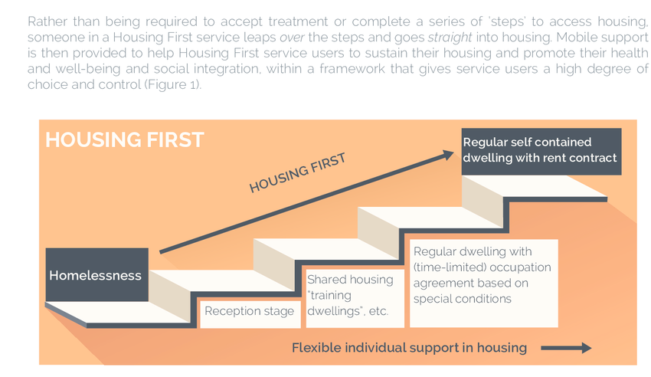

Figure 1. Staircase Model vs. Housing First (Pleace 15).

**The State of Homelessness in the U.S.**

The current state of homelessness in the United States is causing frustration to soar among citizens. In Los Angeles, “over one in five voters…seriously considered moving because of homelessness in their neighborhoods” (Oreskes). LA alone has “an estimated homeless population of nearly 40,000” (Alpert 1) out of 580,000 total homeless in the United States reported in 2020 (National Alliance to End Homelessness (NAEH)).

Current data are inconclusive on improvement and it is unclear today how many homeless there are. A national point-in-time snapshot in 2021 showed an 8% decrease in sheltered homeless from 2020 (HUD). However, the same report did not count unsheltered homeless due to a waived requirement in response to COVID-19. This drop may be influenced by increased distance between beds to prevent virus transmission, resulting in less beds per shelter (NAEH). But the reporting methodology from Housing and Urban Development only includes people that surveyors find in a single night (HUD). As a result of this methodology, the national count is most likely even greater.

Demands for action focus on removal and relocation to alleviate observed increases of “crime, impact to business and home values, filth…and drugs” (Albright). However, the perceived increase in crime can likely be attributed to cities and states criminalizing behaviors associated with being homeless. In 2019, the National Homeless Law Center conducted a study on these laws over a period of 13 years. Bans on camping have increased 92%, sitting or lying down by 78%, loitering and panhandling by 103%, and living in vehicles by 213%. Additionally, “76% of cities prohibit…scavenging or ‘dumpster diving’” (14). This perceived increase in crime rates is likely a result of fear-mongering rather than the rapid increase in laws that criminalize homelessness.

**What are the causes of homelessness?**

Many people blame policy failures to clear homeless encampments as the issue (Associated Press). Others believe that “mental illness, alcohol and drug addiction” are the primary causes of one becoming homeless and those “down on their luck [are] probably…the smallest percentage” (Albright). However, The NAEH, a nonprofit organization “whose sole purpose is to end homelessness in the United States”, aggregated and analyzed data to determine the principal contributing factors. The evidence points to a combination of stagnant wages, rising rent, and lack of affordable housing as the primary causes. Decreasing rent affordability as a measure of wages is rapidly spiking in cities. Financial experts advise that no more than 30% of household income is spent on rent, but major cities are quickly surpassing that threshold (see Figure 2). These increased housing costs without comparable wage increases will only exacerbate the crisis, especially since 64% of Americans are currently living paycheck-to-paycheck (Dickler). The massive amount of inflation the U.S. is experiencing will also factor in and “experts project the pandemic recession could cause chronic homelessness to increase 49% over the next four years” (“Homelessness: Last Week Tonight” 1:21-1:28).

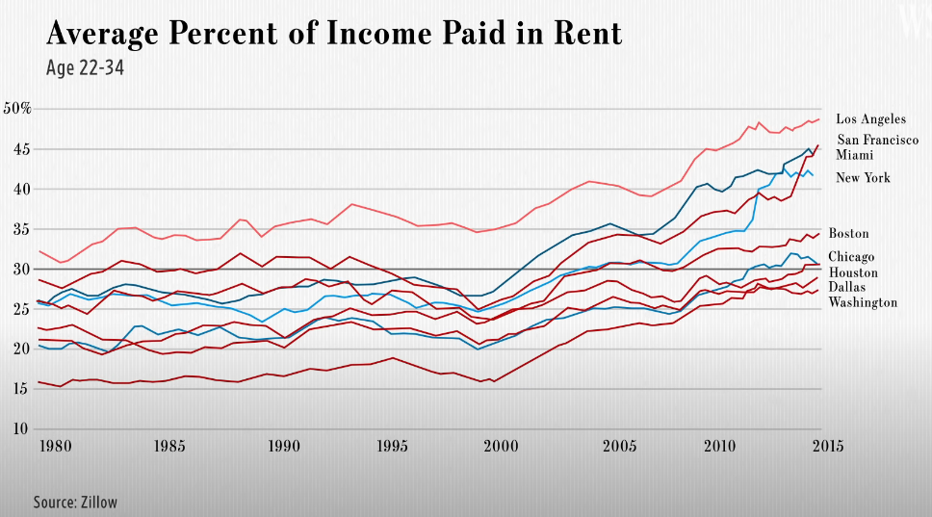

Figure 2. “Rent is growing faster than the money most people make to pay it” (WSJ 00:00-0:24).

This increasing disparity between housing affordability and wages can arguably be attributed to a large transfer of purchasing power to the highest income earners. Since 1971, the middle class has shrunk from 61% of adults to 50% while lower-income adults increased from 25% to 29%. The upper-income tier has also increased from 14% to 21%. However, half of all available income now goes to the higher income earners, an increase from 29% since 1971. Yet purchasing power of the dollar has remained relatively the same (Pew Research Center). This data is indicative of a pattern of an increasing concentration of economic power residing with fewer individuals – power that has been transferred from the majority of other Americans.

From 1948 to 1973, compensation earned and a worker’s productivity were directly correlated. But after 1973 until 2013, hourly compensation only rose 9.2% whereas productivity rose 74.4% (see Figure 3). This would mean that if income kept pace with productivity, then the minimum wage today would be nearly $23 per hour (Lawrence et. al). This decoupling of productivity with wages is correlated with declining union membership and mirrored with the increase of income to the highest earners despite GDP per capita increasing over 1,000% (MacroTrends).

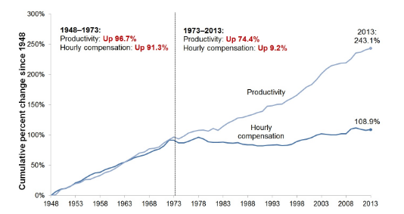

Figure 3. Disconnect between productivity and worker compensation (Lawrence et. al).

Another contributing factor is chronic health issues, suggesting that there is merit to mental illness and substance abuse as a cause to homelessness. “In 2017, 20 percent of the homeless population reported having a serious mental illness [and] 16 percent conditions related to chronic substance abuse” (NAEH). Racial inequality is also a contributor and the economic echoes of racially-disparate laws continue today. For example, Redlining “discouraged economic investment, such as mortgage and business loans, in Black and brown neighborhoods” (NAEH). The policy prevented the accumulation of generational wealth that continues to affect minority groups today. Representing 13% of the total population, African Americans make up “39 percent of people experiencing homelessness and more than 50 percent of homeless families with children” (NAEH). In essence, racial inequality is a contributing factor to the economic inequality we see today.

**The Staircase Model (SM) – An obsolete approach**

Citizens concerned about homelessness and the current economic conditions in the U.S. want affordable and fast solutions. In an interview conducted with a fiscally-conservative family, they state “[what is] really missing is protecting law-abiding taxpayers from the downside of homelessness around them. At some point, if [homeless people] are getting help from the government, they need to eventually be accountable for themselves and off government subsidies” (Albright).

Källmen describes SMs as an education and support program, ensuring that those who are homeless receive the skills they need before they are deemed worthy of a subsidized home (See Figure 1). There are strict rules and accountability measures such as “total abstinence from drugs and alcohol and [requiring] to participate in psychiatric treatment (Pleace 14). However, if a homeless person fails on one of the steps or violates the rules, they are punished by being forced to revert back to the previous step or kicked out of the program (Källmen 1-2). Even so, it is understandable that taxpayers want “to make individuals progress step-by-step in order to show that they are “housing ready”” (Denvall et. al 4) so their tax dollars are not wasted.

But from a homeless person’s perspective and as evidence shows, these albeit well-intentioned programs can be harmful and exacerbate the issue. Pleace describes ethical concerns with SMs that misguidedly approach support with the view of homeless people having character flaws and the cause of their own homelessness (15). It can be argued that the continued prevalence of SMs is a result of this sentiment among the public. Additionally, SMs “could be harsh environments for homeless people” and were expensive with debatable effectiveness (15). Around “40-60% of homeless people with high support needs” were dropped from their SM support system in 2008 (22), thus perpetuating the crisis. Taxpayers would have their concerns amplified if their tax dollars are used on an ineffective and wasteful program, especially if it perpetuated an issue the program was trying to solve. These ethical, effectiveness, and cost drawbacks of SMs are solved by switching to a HF approach.

**Housing First – The Best Solution**

HF places a homeless person or family inside a government-subsidized home as a first step “rather than an end goal” (12). Denvall et. al present convincing evidence that HF is extremely effective when combined with other support and intervention methods (4) (See Figure 4). With help from staff operating under a framework of core principles, recipients will receive support such as home suitability inspections, budgeting, and advice and support (Pleace 40-41) (See Figure 5). With such combination, up to 90% of HF recipients stay in their homes and “leads to [faster] recovery in terms of autonomy [and] increased quality of life” (Denvall et. al 5).



Figure 4. Intervention and support methods for HF

recipients (Pleace 41).

A key differentiating factor between HF and SMs is giving recipients “high degree[s] of choice and control” (Pleace 12). Namely, recipients are not required to abstain from drugs and alcohol but are instead encouraged to (12). This will most likely pose an earlier-mentioned concern by taxpayers of funding such a lifestyle without accountability measures. But with HF, simply removing the stress of living on the street (or subjection to a SM) shows substantial improvement in health and well-being. When implemented in Amsterdam, 70% of recipients reduced drug use, “89% report[ed] improvements in quality of life, and 70% reported improvements in mental health”. Additionally, substance abuse overall was “stabilized or reduced” (21). Recipients saw better social integration and stability in their lives (20-22). By giving recipients of HF agency in their decisions, alcohol and drug use will naturally fall. With some HF models requiring a “30% contribution of income towards rent” (56), there is inherent financial accountability for the individual. With less disposable income of recipients, purchasing power of substances decreases.

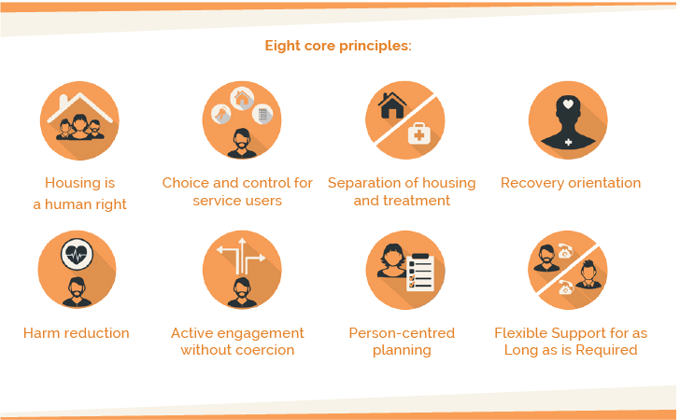

Figure 5. Core Principles for providing HF support (Pleace 13).

Additionally, HF is “more efficient than [SMs]” (Denvall et. al 5) and is extremely cost-effective. “(69%) of the costs of [HF are] offset by savings in other costs, such as emergency shelters” (Latimer et. al 1), “psychiatric services, emergency medical services, and the criminal justice system” (Pleace 16). Those services are extremely costly at the expense of taxpayer dollars due to compulsory admission and prosecution by law enforcement. But there are still concerns from taxpayers who, when presented with the fact of cost-offsetting, say, “it’s gotta be 100% or more of the cost” (Albright). There are some cases in which the program meets or exceeds those expectations. Pleace provides an example of one HF program being 26% less expensive than traditional homeless shelters. Another example from London showed their SM was nearly twice as expensive as HF when excluding recipient-provided rent (16). Factoring in that rent, paid for by a percentage of the recipient’s income, it is reasonable to assume that there would be even greater savings.

The challenges of implementing HF are substantial. There needs to be collaboration with private renters, use of social rented housing, and development of new housing (55). There will be considerable renovation and development costs, collaboration hesitancy from the private sector, “not in my back yard” attitudes, and solving the underlying economic issues which primarily cause homelessness in the first place (55-56).

An additional challenge will be gaining buy-in from voters who strongly believe in the orthodox SM approach. This can be overcome with evidence-based messaging that highlights wasteful spending and ineffectiveness of SMs compared to HF, demonstrating a humanitarian and financial need for the shift. Analyses need to be done on cost-offsetting. The cost-offsetting analysis would not only need to include cost reduction in other programs and services, but also increases for property values and business revenue. Offsetting of soft costs would also need to be included such as perceptions of city dereliction, feelings of safety, and inhumane view of homelessness victims.

**Conclusion**

The conclusive evidence presented above strongly supports transitioning to HF programs from existing SM programs. There also needs to be a comprehensive adjustment of the underlying economic issues which primarily contribute to homelessness. But the academic and scientific evidence directly contradicts the sentiment that “[we] can’t solve it and they don’t want help” (Albright). To alleviate the pain and enact a sustainable social safety net, evidence supports permanent HF with support services as the most effective approach (Fowler, et al. 7). Although some HF models have not been completely fruitful, the successful examples from around the world can serve as a model for future implementation of HF. Criteria for determining such a model, in conjunction with effective messaging, would include positive impact on recipients and comprehensive cost-offsetting analysis.

Homelessness won’t be solved overnight and it will never be solved completely. There is no “silver-bullet” solution, but rather a comprehensive and systematic approach of economic policies and subsidized housing (NAEH). By initially targeting the highest-need individuals and families, a significant portion of the homeless population can be helped immediately in this worsening crisis.

Works Cited

Albright, Russ and Judi. Personal interview. 13 Jun. 2022.

Associated Press. (2022, March 11). *Liberal US cities change course, now clearing homeless camps*. Fox News. Retrieved May 20, 2022, from https://www.foxnews.com/politics/liberal-us-cities-change-course-clearing-homeless-camps.

Bensky, Eric, et. al. “Housing Not Handcuffs 2019.” *National Law Center on Homelessness and Poverty*, Dec. 2019, <https://homelesslaw.org/wp-content/uploads/2019/12/HOUSING-NOT-HANDCUFFS-2019-FINAL.pdf>. Accessed 29 Jun. 2022.

Denvall, Verner, et al. “De-Implementation: Lessons to Be Learned When Abandoning Inappropriate Homelessness Interventions.” *International Journal on Homelessness*, 2022, pp. 1–17. *Crossref*, https://doi.org/10.5206/ijoh.2022.2.13709.

Dickler, Jessica. “As Inflation Heats up, 64% of Americans Are Now Living Paycheck to Paycheck.” *CNBC*, 8 Mar. 2022, www.cnbc.com/2022/03/08/as-prices-rise-64-percent-of-americans-live-paycheck-to-paycheck.html.

“Homelessness in America.” *National Alliance to End Homelessness*, 6 Mar. 2019, endhomelessness.org/homelessness-in-america.

*How California is Redefining Rent Control | WSJ. YouTube,* 30 Dec 2019, <https://www.youtube.com/watch?v=nlIiwrzY1P0>. Accessed 23 Jun. 2022.

*HUD Releases 2021 Annual Homeless Assessment Report Part 1*. (2022, February 4). [Press release]. https://www.hud.gov/press/press_releases_media_advisories/hud_no_22_022#:%7E:text=Sheltered%20Chronic%20Homelessness-,The%20number%20of%20sheltered%20individuals%20with%20chronic%20patterns%20of%20homelessness,decrease%20for%20all%20sheltered%20individuals.

Källmen, Håkan. “Free from Homelessness: Is ‘Housing First’ the Solution? - A Comparison with the ‘Staircase Model’. A Feasibility Study.” *International Archives of Addiction Research and Medicine*, vol. 2, no. 1, 2016. *Crossref*, https://doi.org/10.23937/2474-3631/1510016.

Kochhar, Rakesh, and Stella Sechopoulos. “How the American Middle Class Has Changed in the Past Five Decades.” *Pew Research Center*, 21 Apr. 2022, www.pewresearch.org/fact-tank/2022/04/20/how-the-american-middle-class-has-changed-in-the-past-five-decades.

Latimer, Eric A., et al. “Cost-Effectiveness of Housing First With Assertive Community Treatment: Results From the Canadian At Home/Chez Soi Trial.” *Psychiatric Services*, vol. 71, no. 10, 2020, pp. 1020–30. *Crossref*, https://doi.org/10.1176/appi.ps.202000029.

Lawrence, Mishel, et al. “Wage Stagnation in Nine Charts.” *Economic Policy Institute*, 6 Jan. 2015, www.epi.org/publication/charting-wage-stagnation.

Oliver, John. *Homelessness: Last Week Tonight with John Oliver*. *YouTube*, 1 Nov. 2021, <https://www.youtube.com/watch?v=L4qmDnYli2E>. Accessed 22 Jun. 2022.

Oreskes, B., & Lauter, D. (2021, December 1). L.A. voters angry, frustrated over homeless crisis, demand fast action, poll finds. *Los Angeles Times*. Retrieved May 19, 2022, from <https://www.latimes.com/homeless-housing/story/2021-12-01/la-voters-are-frustrated-impatient-over-persistent-homelessness-crisis>.

Pleace, Nicholas. *Housing First Guide Europe*. University of New York, 2016.

“U.S. GDP Per Capita 1960–2022.” *MacroTrends*, 2022, www.macrotrends.net/countries/USA/united-states/gdp-per-capita.